****ZPAV

POLAND

**What can I declare?**

You can declare the sales of both audio and/or videos. Both forms are very similar. You can declare both physical and digital sales as well as revenue received from the licensing of recordings in Poland.

You must also declare the cost of licensing recordings from other parties for a product in Poland.

**Which form should I use?**

You need to complete **both form A and B, regardless of whether you have only had sales from one category**. The two categories are ‘phonograms and music videograms’ and ‘music videograms’ only.

**Should the Sales be in Sterling or Złoty?**

ZPAV request that you declare the revenue in Polish Złoty (PLN).

**What period does this cover?**

2024 - 1st January 2024 until 31st December 2024.

**What does each field mean?**

The form requires four figures, they are:

|  |  |
| --- | --- |
| 1 | The net value (in PLN) of sales of physical products sold in and/or exported to Poland |
| 2 | The net value (in PLN) of digital sales in Poland |
| 3 | The net value (in PLN) of revenue received from licensing (recordings/ videograms etc.) |
| 4 | The cost of licensing (recordings/videograms etc.) from third parties |

Pleases see example below to assist with the understanding the licencing questions (3 & 4):

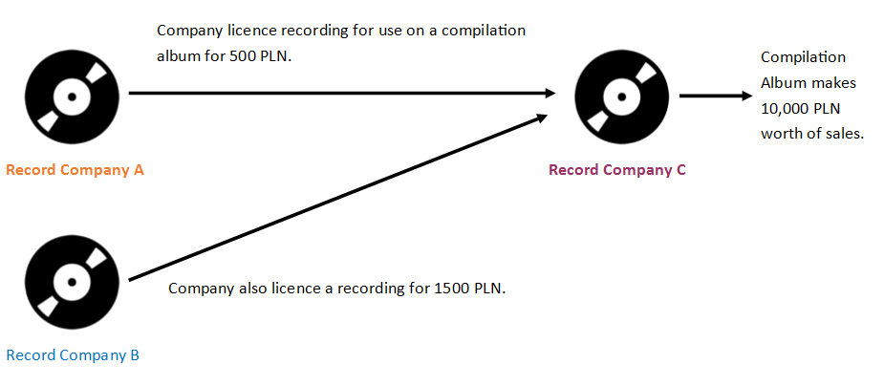

Record Company A would therefore complete the form as below:

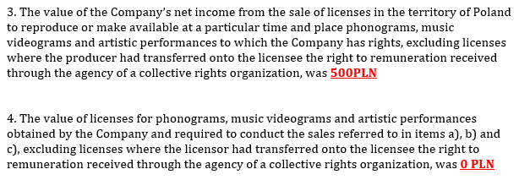



Record Company B would therefore complete the form as below:

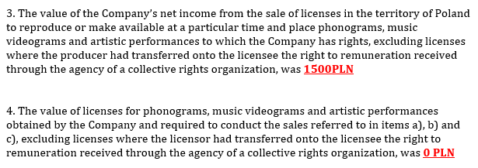



Record C would complete the form slightly differently:

