
AGEDI
SPAIN

Should I be declaring to AGEDI?
You should only declare sales data to AGEDI if you have mandated PPL to collect in Spain.

What can I declare?
You can declare sales of PHYSICAL products distributed within Spain.

What territories should I declare sales data for?
Please include sales information for:
- Spain

Should I use Euro or Sterling?
Sales must be declared in Euro
What period does this cover?
There are four sales data deadlines for AGEDI:
Country |  | CMO | Period of sales |  | Member Deadline
Spain |  | AGEDI | Q4 2025 |  | 16/03/2026
Spain |  | AGEDI | Q1 2026 |  | 19/06/2026
Spain |  | AGEDI | Q2 2026 |  | 18/09/2026
Spain |  | AGEDI | Q3 2026 |  | 11/12/2026

Where can I find information regarding sales in this territory?
Your distributors and retailers may be able to provide you with the sales figures for the specific territory. The sales figures must be for territories listed above only, not worldwide.

What information do I need to complete the form?
Data Required |  | Is this mandatory?
PPL Member Name | Your Rightsholder Name as it appears in MyPPL. This was also included on the Sales Data email. | 
PPL Member ID Number | Your PPL Member ID as it appears in MyPPL. This was also included on the Sales Data email. | 
Sales
Owned Product | Total Value of Physical Sales during declaration period | 
Distributed Product | Total Value of Physical Sales during declaration period of non-owned repertoire | 
Name of Original Producer | Names and Addresses of the original producers whose non-owned repertoire has been distributed | 

Example of Completed Form
- Owned Product Only:
Example of Declared Value €25

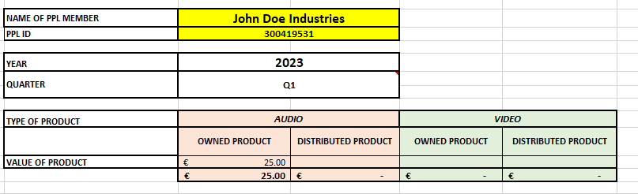

- Owned and Distributed Product:
Tab 1
Example of Declared Values of Owned Product €25 & Distributed Product €5

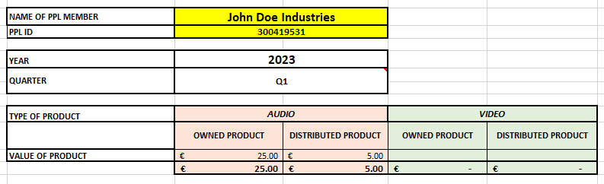

Tab 2

