
AUDIOGEST
PORTUGAL

Should I be declaring to Audiogest?

You should only declare sales data to Audiogest if you have mandated PPL to collect in Portugal.

What can I declare?

You can declare physical sales sold in Portugal only.

Can I declare digital sales for Audiogest?

No. You can only declare the sales of physical products.

What period does this cover?

The period for which you need to declare for is from January to December 2024.

What territories should I declare sales data for?

Please include sales information for Portugal only, not worldwide.

Where can I find information regarding sales in this territory?

Your distributors and retailers may be able to provide you with the sales figures for the specific territory.

The sales figures must be for Portugal only, not worldwide.

Should the sales be in sterling or Euro?

Please declare your sales in Euros (totals without VAT). Please do not declare negative values.

Do I have to provide evidence of sales declared?

Yes - please provide evidence of the sales declared in the form. Supporting documents may include: extract from distributors, invoices, or accounting reports.

What information do I need to complete the form?

Please provide the following information:

Data required |  | Is this information Mandatory
PPL Member Name | Your Rightsholder Name as it appears in MyPPL. This was also included on the Sales Data email. | 
PPL Member ID | Your PPL Member ID as it appears in MyPPL. This was also included on the Sales Data email. | 
Sales Year | 2024 | 
Distributor | Name of the Distributor or Third Party Distributing in Portugal | 
Label/Album | Label Name / Album Title | 
Amount | Sales in EUROS (without VAT).  Do not report negative amounts. Negative amounts are not accepted. | 

What information is required?

For physical sales Audiogest require:

- In the top part of the form, top box:

MEMBER | Physical Sales (only in Portugal)
a) | Albums | Singles | Music Videos | TOTAL Physical
Total | b) | b) | b) | b)

- Member: Name of PPL Member and PPL Member ID
- Physical Sales value (only in Portugal), declared in Euros (without VAT):
Insert the total value declared of Albums, singles, and music videos.
Check the Total Physical amount declared is correct.

- Exclusive information regarding the Physical Market:

PPL Members qualify to declare sales in Portugal when:
- RRH holds the rights in Portugal (Table 1 Answer: NO) and is not the distributor in Portugal, a third party distributes in Portugal (Table 2 Answer: YES)

- RRH holds the rights in Portugal (Table 1 Answer: NO) and is the distributor in Portugal (Table 2 Answer: NO)

Example of a completed form:

- RRH holds the rights in Portugal (Table 1 Answer: NO) and is not the distributor in Portugal, a third party distributes in Portugal (Table 2 Answer: YES)

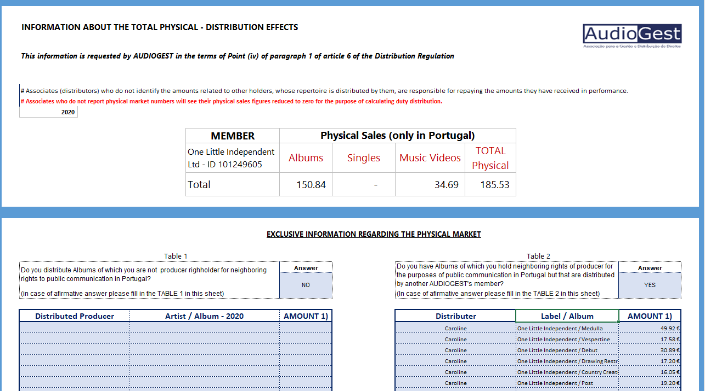

- RRH holds the rights in Portugal (Table 1 Answer: NO) and is the distributor in Portugal (Table 2 Answer: NO)
