
MAHASZ
HUNGARY

What can I declare?
You can only declare products that have been registered in the PPL database.

Should I use Hungarian Forint (HUF) or Sterling (GBP)?
Net value of sales must be provided in Hungarian Forint (HUF).

What period does this cover?
You must only submit data for the period: January – December 2025.

Will MAHASZ ask for evidence?

Please note that unless you provide proof of sales of your sound recordings in the territory of Hungary (both digital and physical), MAHASZ will not be able to distribute revenues to you.

The acceptable evidence can be official proof of sales (invoices, official sales reports) which identifies the rightsholder, the supplier, the amounts, the territory (Hungary) and the sound recordings. In order to accept the submitted data, MAHASZ may ask for further evidence of these sales, including (but not limited to) contracts, invoices, summary of sales from digital providers and the company’s financial accounts for the year in question.

The data should reflect all net sales made in the territory of Hungary in the relevant period.

See end of FAQ’s for further information from Mahasz on acceptable sales.

Where can I find information regarding sales in this territory?
Your distributors and retailers may be able to provide you with the sales figures for the specific territory. The sales figures must be for Hungary only, not worldwide.

What information do I need to complete the form?
Data Required |  | Is this mandatory?
PPL Member Name | Your Rightsholder Name as it appears in MyPPL. This was also included on the Sales Data email. | 
PPL Member ID Number | Your PPL Member ID as it appears in MyPPL. This was also included on the Sales Data email. | 
Email Address | Your email address | 
Phone Number | Your contact phone number | 
Units | Specify the number of units sold | 
Net Value | Specify the net value of units sold in HUF | 
Example of a completed form:

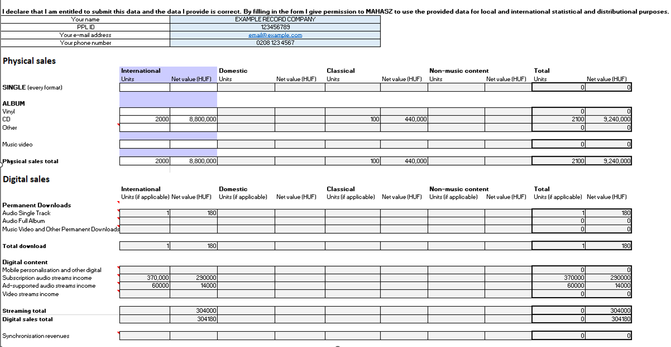

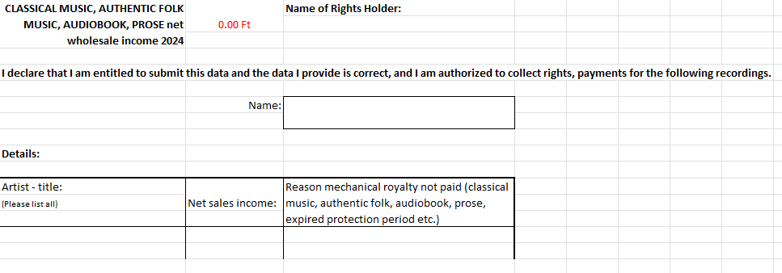

What is the difference between Domestic and International sales?
‘Domestic’ refers to the sales, in Hungary, of tracks or albums where the Country of Commissioning and/or Country of Recording is Hungary.

‘International’ refers to the sales, in Hungary, of tracks or albums where the Country of Commissioning or Country of Recording is not Hungary.

Should all classical music be declared separately to domestic or international sales?
Yes, all classical music should be separated, regardless of whether it is domestic or international.
Please add them to the Classical tab.

What should I include in the ‘Other’ section?
Cassette, MiniDisc, DVD Audio, SACD and other albums.

What does SACD mean?
SACD stand for Super Audio CD. It is a high quality format for listening to music, comparable to Blu-ray vs DVD

Does ‘Subscription Streams Income’ include Spotify and Apple Music?
Yes.

Should I declare sales under distribution deals?
Sales under distribution deals should not be reported by the company distributing the repertoire and should reflect the net billings from the sale of the third party product.

Should I declare the sales of compilations released by a third party that featured a track I own?
No, all compilation physical product sales should be reported by the company distributing the release. License revenues from companies not distributing the compilation should be excluded.

How do I declare mixed content bundles?
Sales of a single product (single transaction) including more than one format should be reported under the main format within the product.

Can I declare free goods?
MAHASZ allow you to include free goods distributed for normal sales to consumers (‘commercial free goods’).

FURTHER INFORMATION ON ACCEPATBLE SALES DATA BY MAHASZ:
Trade Value Definition:
Physical
Companies should report net (VAT excluded) sales of physical products (including distributed content). Figures should reflect shipments net of returns, net of discounts, net of taxes, net of handling charges and adjusted for the effect of sales allowances.
Physical sales should include retail, club/mail order, door-to-door, made-to-order and premium sales. Sales of physical products via local online retailers should be included.
Sales under distribution deals should be reported by the company distributing the repertoire and should reflect the net (VAT excluded) billings from the sale of third party product (i.e. the gross sales, less returns and discounts before amounts remitted to third party labels). Sales from licensed out deals, where the record company licenses a third party to exploit their repertoire, should be excluded from the repertoire owner’s sales and included in the licensee’s reported figures. License/distribution fees earned from license out deals should be excluded.
All compilation physical product sales should be 100% reported by the company distributing the release. License revenues from companies not distributing the compilation should be excluded.
Include premium sales - product sales made under non-conventional terms, where the products are: a) specially produced (i.e. not offered as part of the company’s standard catalogue) for another company that does not usually sell/distribute recorded music; b) specially priced for one particular offer/campaign (i.e. products from standard catalogue sold at a wholesale price significantly below the price charged to regular retail accounts), or c) when the sale is ‘one-way’ (returns not accepted at any time).
Free goods distributed for normal sale to consumers (‘commercial free goods’) should be included. Goods distributed to radio and other media for promotional purposes (‘promotional goods’) should be excluded.
Sales of physical products via own-company websites (direct to consumer sales) should be included. Full net (VAT excluded) retail value should be reported as trade revenue.
Mixed content bundles: sales of a single product (single transaction) including more than one format should be reported under the main format within the product.
Exclude income from activities other than the direct sale of sound recordings. Income from legal settlements from anti-piracy cases should be excluded. Exclude wholesale export sales. Exclude promotional products (samples, gifts, etc.). Exclude income from legal settlements from anti-piracy cases.
Digital
Income from digital music content sales in the territory of Hungary only (incl. distributed content). Figures should be reported net of discounts and net of taxes. Trade sales should reflect net (VAT excluded) invoiced amounts as stated in the company's financial accounts. Companies reporting on an accrual’s basis should adjust revenues when the actual retailer reports are made available. These adjustments should be made in the current period, not retrospectively.
Sales under distribution deals should be reported by the company distributing the repertoire and should reflect the net (VAT excluded) billings from the sale of third party product (i.e. the gross sales less discounts before amounts remitted to third party labels). Sales from license out deals, where the record company licenses a third party to exploit their repertoire, should be excluded from the repertoire owner's sales and included in the licensee's reported figures. License fees earned from license out deals should be excluded.
Sales of joint-venture based digital products (including compilations/soundtracks) should be 100% reported by the company distributing the release. License revenues from companies not distributing the compilation should be excluded.
Digital premiums (consumer promotions involving digital products where the company gets a fee - e.g. deals with Pepsi/McDonalds) should be reported in the appropriate revenue stream category (e.g. If it's a premium deal for downloads, income should be reported under 'Downloads').
Digital income from own-company websites should be included; full net (VAT excluded) retail value should be reported as trade revenue (as per financial accounts).
Ensure that there is no double-counting of product sales.
Only transactional earnings from global/regional deals should be reported. Transactional earnings should be reported in the respective category (e.g. If it is income relating to downloads, it should be reported under "downloads"). Unearned advances from global deals pushed down to the territories at the end of the contract or on an accruals basis should be excluded.
Exclude any income outside of Hungary and all monies received from collecting societies relating to performance rights/neighbouring rights. Exclude unearned advances and one-off payments relating to digital products. Exclude set up fees/operational income for content provision to third parties. Exclude distribution fees and income from legal settlements from anti-piracy cases. Exclude any fees collected on behalf of publishers, even if the music company is also the publisher. Exclude intercompany sales.

