
STAP
NETHERLANDS

Should I be declaring to STAP?
You should only declare sales data to STAP if you have mandated PPL to collect in The Netherlands.

What can I declare?
You can only declare products that have been registered in the PPL database.

You can declare sales of physical and digital products distributed within The Netherlands.

What territories should I declare sales data for?
Please include sales information for:
- Netherlands

Should I use Euro or Sterling?
Sales must be declared in Euros.
What period does this cover?
1st January 2023 until 31st December 2025.

Where can I find information regarding sales in this territory?
Your distributors and retailers may be able to provide you with the sales figures for the specific territory. The sales figures must be for territories listed above only, not worldwide.

What information do I need to complete the form?
- Own Product Only:

Data Required |  | Is this mandatory?
PPL Member Name | Your Rightsholder Name as it appears in MyPPL. This was also included on the Sales Data email. | 
PPL Member ID Number | Your PPL Member ID as it appears in MyPPL. This was also included on the Sales Data email. | 
Address & Post Code | Address & post code of record label/RRH | 
Sales
Total Turnover (A) | Total Value of Digital and Physical Sales during declaration period.  Please also complete Section 1 – physical/digital sales breakdown. | 

Example of Completed Form:

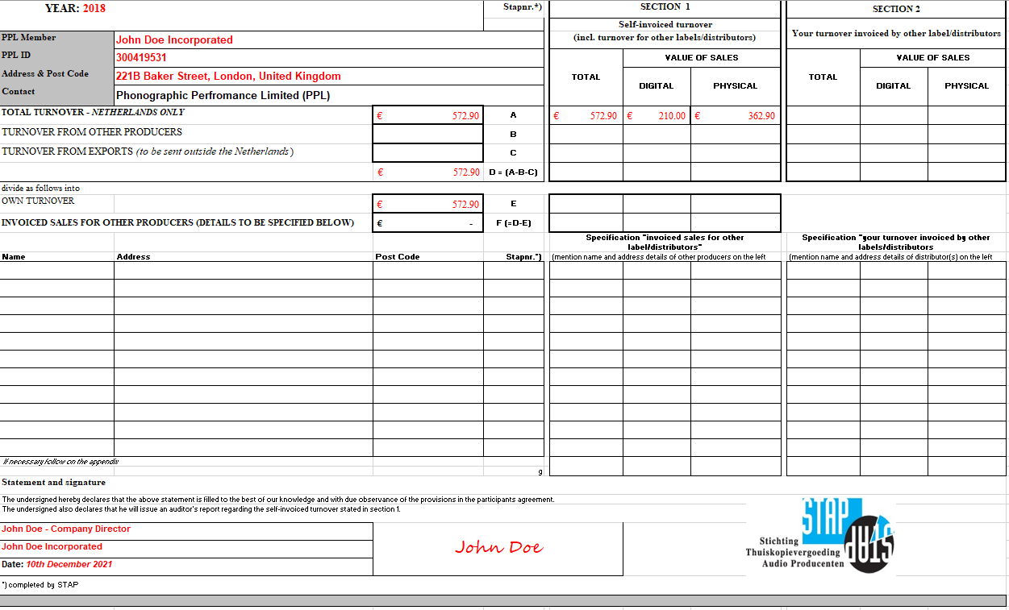

- Owned and Distributed Product

Data Required |  | Is this mandatory?
PPL Member Name | Your Rightsholder Name as it appears in MyPPL. This was also included on the Sales Data email. | 
PPL Member ID Number | Your PPL Member ID as it appears in MyPPL. This was also included on the Sales Data email. | 
Address & Post Code | Address & post code of record label/RRH | 
Sales
Total Turnover (A) | Total Value of Digital and Physical Sales during declaration period.  Please also complete Section 1 & 2 – physical/digital sales breakdown. | 
Turnover from Other Producers (B) | Total Value of Digital and Physical Sales of owned & distributed product during declaration period | 
Own Turnover (E) | Names and Addresses for any sales invoiced to or by other labels/ distributors | 

Example of Completed Form:
